The Pilates Fab 5 Stomach Series

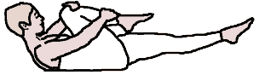
- Single Leg Stretch
- To mimic athletic and walking movements of hips and pelvis
- requires on hip to open and one to fold

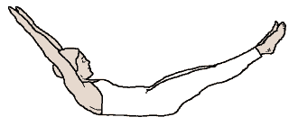
- Double Leg Stretch
- Weight of legs and arms challenge abdominal control and endurance
- requires adaptability of breath work and bone rhythms
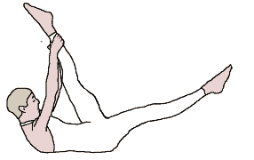
- Scissors
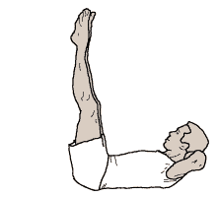
- Challenges left and right side during transitions
- Requires ability to access control and awareness

- Double Leg Lift and Lower
- Extremely challenging to put hands behind head and control legs
- Requires strength and control of abdominals to protect back and engage legs

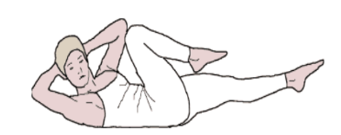
- Criss Cross (Bicycle)
- Rotation quality being challenged to the max
- Requires the ability to move ribcage to turn

Exercises:
Warm Up: 1. Breathing
2. Pelvic and Leg Movements
3. Spinal Rotation

Single Leg Stretch: Toe Dips Curl Up Leg Stretch
Double Leg Stretch: Double Leg Dips Take Hat Off Leg Reach to Ceiling
Scissors: Reciprocation of legs Reaching Quality Lengthen Waist
Double Leg Lifts: Plug Legs Into Sockets Turn Legs Out Lower & Lengthen
Criss Cross: Bicycle Turn Reciprocating Legs Turn Breastbone

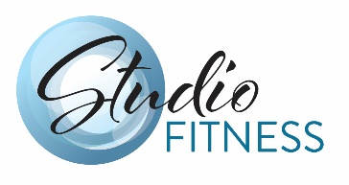
Explore More:
https://www.easyvigour.net.nz/fitness/h_Free_Pilates_Exercises.htm
Exercise instruction with pictures along with basic principles and breathing.

https://studiofitnessvictoria.com/workshops

